**Kickstart Data Report**

**So basically,** we started with a dataset of 4,000 projects, and like instructed we created additional columns called, Percent Funded and Average Donation. The Category and Sub-Category featured in separate columns labelled, Category (Parents Category) and Sub-Category, to more accurately define the results in later analyses. Next, we organised exploratory data analysis to quickly identify any trends by colour coding the outcome and percent funded categories.

1. **Conclusion about Kickstarter Campaign by given data**

Analysing data for 4000 past Kickstarter projects depending upon the categories. As we examined the relationship between the project category and its outcome to determine which category was successful, failed, canceled, and live. Below figure shows the different outcomes by Category or parent category.

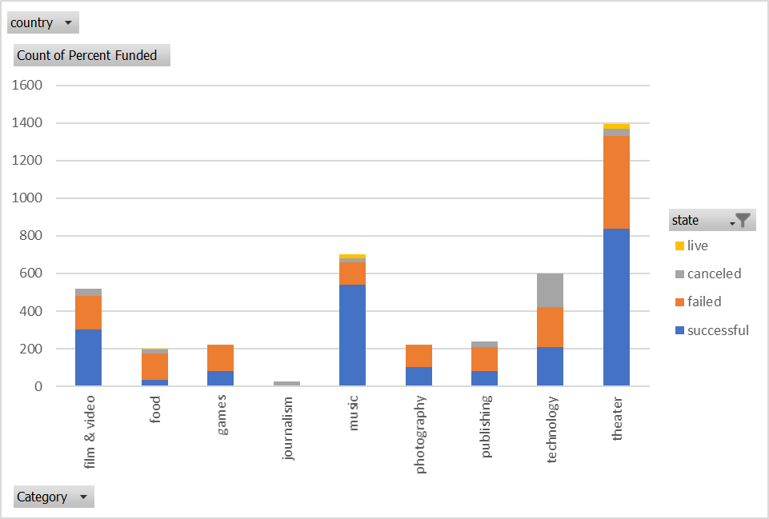

Similarly, we examined relationship between the sub-category and the outcome to analyse which subcategories were successful, failed, canceled, live. Below figure shows the results.

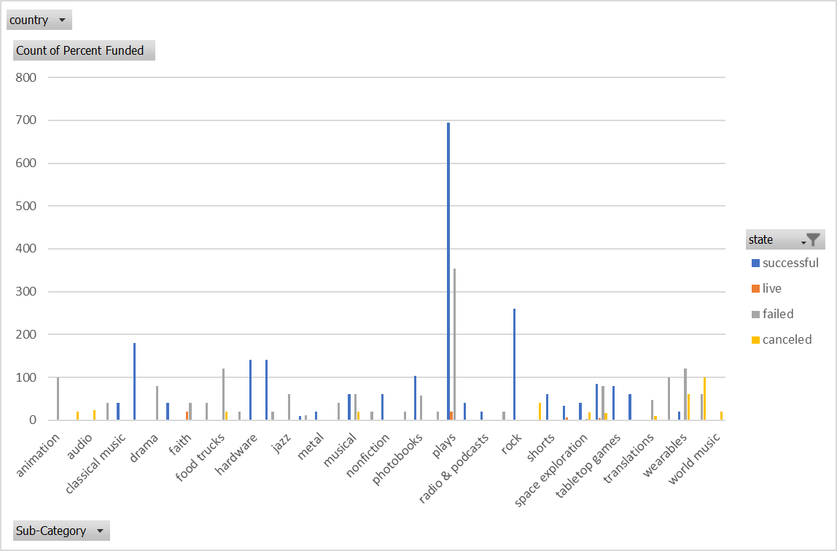

This figure below is a line graph which is based on the time of year/month in which the project was conducted by the following outcomes. The thing to observe here is canceled projects is fairly consistent whereas May month has the most successful project count.

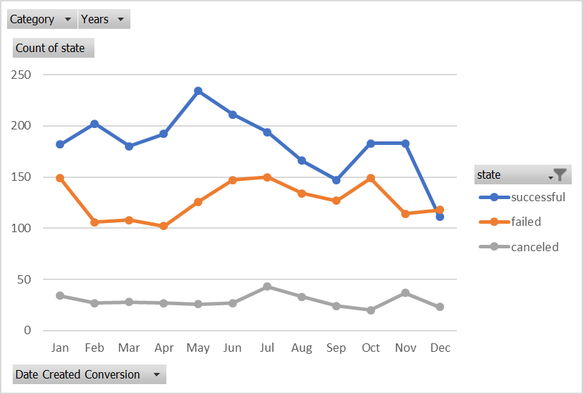

Well the Final conclusion, it apperas that the category with the highest success is Music and subcategory with the most successful project is Rock. The result of our final analysis shows that projects with smaller goals are the most successful and project with goals greater are the least succeed.

**2. Limitations of this dataset**

* The data could not show the success rate or failed rate for each category/subcategory with the current data structure.
* The data has regional limitations. Most of the projects are from United states. It might be not as helpful for people from other counties to rely on the dataset to make the decision
* The data set only have limited amount sub-categories. If we can break down the categories furthermore, it may be more helpful for people to locate the outcome of a specific sub-categories.

**3. Possible tables/graphs that we could create**

* Outcome by country, by state (USA)
* Goal and Pledged amount by both Category and Subcategory